“Bringing Future Technology To The Present”

LiteWorld Protective Enclosure

Plexiglass Enclosure
38” wide x 32” high x 30” deep
Two wide opening front doors
Cooling fan with carbon for odor removal and temperature control
Reduces all printer noise down to under 40 decibels ( library quiet )
Easy to set up and made from durable commercial grade components

Price: $575.00
Plus shipping.

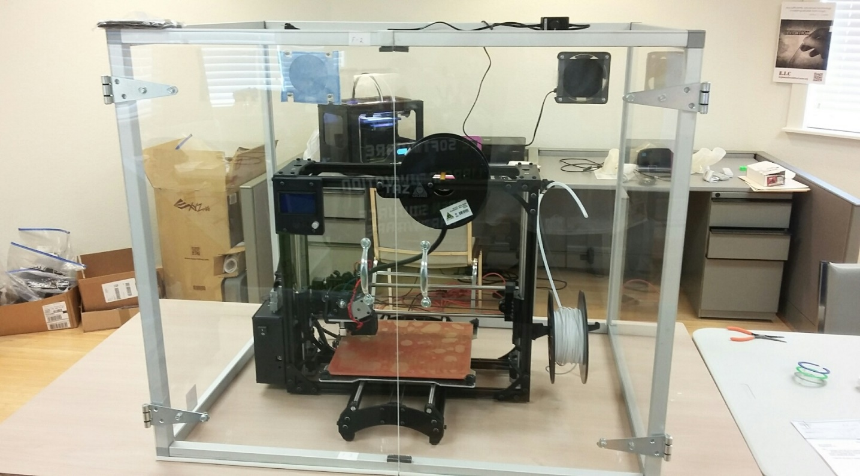

LiteWorld LLC
1141 Arbroid Drive
Englewood,FL. 34223
www.liteworldllc.com
Email: donmusilli@liteworldllc.com
Phone: 941-999-8200

